Thesis Title



Your Name

­

This dissertation is submitted for the degree of Doctor of Philosophy

July 2018

Your Department

Dedication goes here

optional

This page is for a personal statement of quote

optional

Declaration

This thesis has not been submitted in support of an application for another degree at this or any other university. It is the result of my own work and includes nothing that is the outcome of work done in collaboration except where specifically indicated. Many of the ideas in this thesis were the product of discussion with my supervisor xxx.

Excerpts of this thesis have been published in the following conference manuscripts and academic publications.

[Reference list here]

Your Name and full qualifications

Lancaster University, UK

Abstract

See rules in the MARP: <https://gap.lancs.ac.uk/ASQ/QAE/MARP/Pages/default.aspx> as follows:

Each thesis shall be preceded by an abstract not exceeding 300 words typed as specified below in a form suitable for use in major abstract indices.

The text of the thesis shall be word processed on good quality A4 paper (210 mm x 297 mm), leaving a left hand margin of 38 mm, and a margin of 25 mm on the other three sides. Diagrams and illustrations shall be reproduced or mounted on similar paper; any which cannot be folded on A4 size must be submitted in a suitable portfolio which shall bear the particulars listed in 2.4 above.

Until recently double line spacing was a requirement, but this is no longer reflected in the Manual of Academic Regulations and Procedures 2015-6.

The author shall provide as an integral part of the thesis a comprehensive list of contents, including diagrams, illustrative matter and any appendices; bibliography comprehending all materials cited or referred to in the whole submission; and must indicate if any part of the thesis is bound separately

NOTE that each department may and will vary the rules to suit their particular preferences. Consult your supervisor.

Acknowledgements

Thank you to Kayla Friedman and Malcolm Morgan of the University of Cambridge University, UK, and Charles Weir of Lancaster University, UK, for producing the Microsoft Word thesis template used to produce this document.

Contents

1 Introduction 1

1.1 Requirements 1

1.2 Paper and electronic copies of the dissertation 3

2 Using this Template 4

2.1 Getting Started 4

2.1.1 Using the DOCX file 4

2.1.2 Using the DOTX file to start a new document 5

2.1.3 Using the DOTX file to migrate and existing document 5

2.2 Improved Spelling and Grammar Checking 5

2.3 Understanding Styles 6

2.4 Themes 7

2.5 Margins 8

2.6 Headers and Footers 8

2.6.1 Editing Header and Footers 9

2.7 Working with Images 10

2.8 Captions 10

2.9 Cross References 10

2.10 Updating Automatically Generated Content 11

3 Style Examples 12

3.1 Heading 2 13

3.1.1 Heading 3 13

3.2 Heading 2 13

3.2.1 Heading 3 13

4 Information taken from Cambridge Student Registry 17

4.1 Style and Format 17

4.2 Binding 18

4.3 Including Other Written Material 19

4.4 Including a CD-ROM (or other item) 19

4.5 Word Limits and Stylistic Conventions: Requirements Of The Degree Committees 20

4.6 Engineering 20

4.7 Extending The Word Limit 20

5 Information from CUED 21

5.1 Appointment Of Examiners And Approval Of Title 21

5.2 Format of Your Dissertation 21

5.3 Submission of Your Dissertation 22

5.4 Examination Procedure 22

6 From ‘planning a PhD’ 23

6.1 Typing and Printing of Dissertations 23

6.2 Acknowledgements 23

7 References 24

8 Appendices 25

List of Tables

Table 3.1 This is the caption to a table, and the styles used in tables. 14

List of Figures

Figure 2.1: Grammar Options in Word 2010 6

Figure 2.2: The Home Tab in Word 2010 showing Style on the right hand side 6

Figure 2.3: Colour Themes in Word 2010 are on the Page Layout Tab 7

Figure 2.4: Margin Settings in Word 2010 8

Figure 2.5 Cross-reference options in Word 2010 10

Figure 3.1: This is a picture of a running kitten. In addition, this caption style is used to caption pictures and tables. Captions include the numbering system included the chapter number. Captions default to above content. 14

List of Abbreviations and Acronyms

List of Appendices

Appendix Heading 1 16

Appendix 1 Example Title 26

Appendix 2 27

# Introduction

This document is intended to provide useful information about producing a thesis in terms of content, editing, and production of copies. This document was first written with Microsoft Word 2010 in 2013; it was last updated in February 2015. No further updates are planned, and the template is provided “as is” with no promise of ongoing support.

Creative Commons License

The original CSD Thesis Template by [Kayla Friedman and Malcolm Morgan](https://neuraldischarge.wordpress.com/2013/11/05/the-only-phdmasters-thesis-template-for-word-you-will-ever-need/) is licensed under a [Creative Commons Attribution-Non Commercial-Share Alike 4.0 International License](http://creativecommons.org/licenses/by-nc-sa/4.0/). Modifications for Lancaster University are licensed under the same terms.

Further information from

<https://neuraldischarge.wordpress.com/2013/11/05/the-only-phdmasters-thesis-template-for-word-you-will-ever-need/>

Requirements for a PhD / Masters Degree vary. Please check with your own department before submitting.

## Requirements

Note – this section is Cambridge requirements – some details will differ.

#### Dissertation length

The dissertation should be about 65000 words

#### Structure

The structure of the dissertation should broadly follow this outline.

* Abstract. 2-300 words long and give a very brief overview of the whole dissertation, including your findings.
* Introduction
* Middle chapters
  + Aims, methods, data, description, analysis
* Conclusions. The conclusion section should be quite short, 5 pages at the most, and normally 1 or 2. It should:
  + sum up the findings made during your research,
  + have a short introductory section explaining the process of your dissertation,
  + often have recommendations for the future.
  + answer the research question that your dissertation addresses.
* References
* Appendices

IT IS VERY IMPORTANT to check that your chapters link together coherently; at the start of each chapter you might have an introductory paragraph setting the scene for the contents and at the end of each chapter it may help to have a few paragraphs summing up its contents.

Spreadsheets should be inserted as tables.

Some students find Excel using in developing the structure with word counts, etc.

Finally, your title is expected to reflect the content!

#### Interaction with supervisor

It is useful to know when your tutor is generally unavailable, bearing in mind that you will be working on it during the summer holiday period. Make sure you give your text to the tutor so that they have enough time to look at it before any critical date or meeting, Check with your tutor whether they want a printed copy or whether a computer document will do.

**Before** giving document to tutor:

1. If you have trouble with English, ask a friend to check it for you.
2. Do Ctrl-A to select all text and F9 to recalculate. This updates automatic numbering, table of contents etc.
3. Do a spell and grammar check.
4. Tracking changes. If your tutor or someone else edits your document, it is useful for them to use Track Changes (Alt-TT).
5. Read the Word for Thesis writing PowerPoint on the Neuraldischarge site (URL above)

## Paper and electronic copies of the dissertation

We require a bound copy and an electronic copy of your dissertation. .

#### Bound copies

We require two canvas bound copies with hard or soft cover. On the spine the lettering should be in the format:

#### Electronic copies

These should be in Word or PDF format. It is useful to have it on a CD, but if the whole lot can be zipped to under 10MB then you can also email it to your tutor.

# Using this Template

Instructions in this section were written for Word 2010, they are similar in Word 2007, and Word 2013, but may be different in Word 2003 and Word for Mac.

## Getting Started

The most up to date version of the template is available at:

<https://github.com/charlesweir/LUThesisTemplate>

Two different versions are available. The DOCX version is just a normal Word Document, you can use and edit this versions as you would any other document. The DOTX version is a word template and therefore can be applied to an existing document or used as the template to a new document. The DOCX version includes this help text. The DOTX version only includes the standard front matter. The benefit of using the DOTX template is that there is separation of styling and content, which reduces the risk of breaking the template.

### Using the DOCX file

You can use this document to write you thesis, simply delete the help text and start writing into the document.

### Using the DOTX file to start a new document

Create a new document from the template:

File > New > New from existing

The select the DOTX template

A word document will open containing the basic structure of the PhD Template. Scroll down to page 11 and select the text that says “Select this text and the paste your existing document here.”

Delete this text and start writing your thesis.

Remember to use the special style for appendix headings

### Using the DOTX file to migrate and existing document

Create a new document from the template:

File > New > New from existing

The select the DOTX template

A word document will open containing the basic structure of the PhD Template. Scroll down to page 11 and select the text that says “Select this text and the paste your existing document here.”

Now go to your existing document and copy all the text, if you have existing front matter such as cover pages, tables of contents etc do not copy those.

Go back to the PhD Template and past your text.

Select All (Ctrl + A) and then press F9 to update all the automatically generated content. If prompted select Update Whole Table.

You may need to make additional changes to your document such as formatting appendix titles to the appendix style, checking that styles have been correctly applied and repositioning images.

If you have numbered your headings incorrectly in your old document, you may find that the new document has double heading numbers.

## Improved Spelling and Grammar Checking

As default Word does not enable all the spelling and grammar checking features. You can get extra spelling and grammar checks by going to:

File > Options > Proofing

The under “when correcting spelling and grammar in Word” click Settings.

Here you can use the drop down menu to make work check Grammar & Style, and use the tick boxes to choose which features to check for. Most academic writing includes passive sentences so you may wish to turn off this feature. You can also set style features such as comma positions, and number of spaces between sentences. I recommend you set these to “Always, inside, 2.”

Figure 2.: Grammar Options in Word 2010

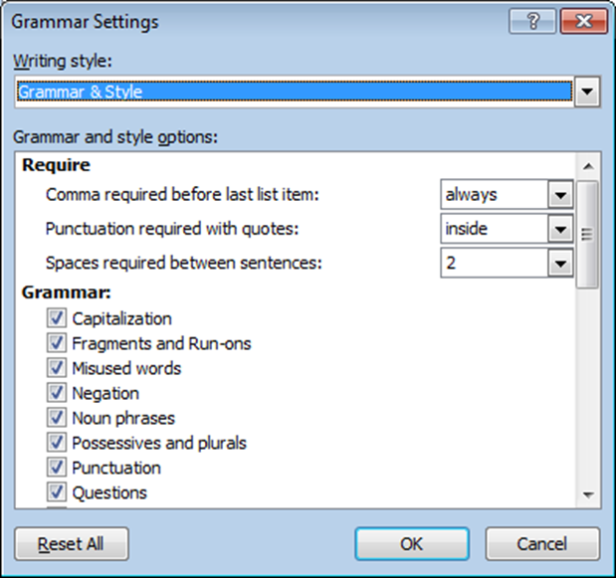

## Understanding Styles

The template makes heavy usage of Word Styles. When used correctly styles save a lot of time and make formatting your document easier. Rather than formatting each piece of text individually, you create styles for different parts of the text e.g. headings, captions, references etc. You then just tell Word what style to use on what part of the text.

Figure 2.: The Home Tab in Word 2010 showing Style on the right hand side

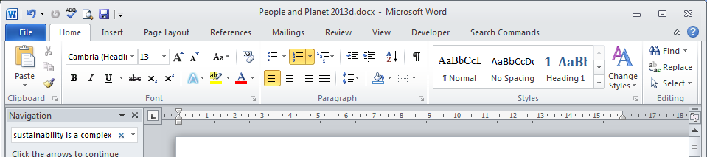

As part of the Template we have created styles which meet the needs of most academic texts. If you do not like the fonts we have chosen you can simple modify the styles and the whole document will change automatically. To modify a style right click on it an select Modify.

Styles are also used to automatically create things like tables of contents.

Styles can be found in the Home Tab in Word 2010 and a list of different styles used and how they appear is on page 12.

## Themes

Themes dictate how your document looks and set colours, fonts etc. They work in partnership with styles. The Theme for the Template is called CSD Template V2 and uses the aspect colour scheme.

Figure 2.: Colour Themes in Word 2010 are on the Page Layout Tab

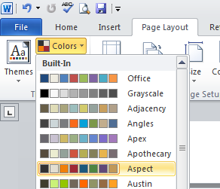

Changing the theme will also affect things like excel graphs pasted into your documents. You can also load the theme into Power Point and Excel to create other content with a consistent appearance.

## Margins

The Template includes margins that comply to the University of Cambridge Standard and are a good starting point. If you have to comply with other rules on Margins, you can change them by going to Page Layout > Margins > Custom Margins.

Remember to apply margins to the whole document, and that you need mirror margins on a thesis with wider margins by the spine. Otherwise, the document will be unreadable when bound.

Figure 2.: Margin Settings in Word 2010

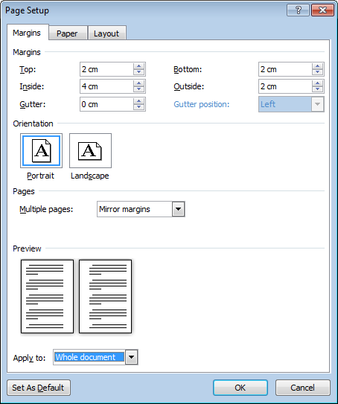

## Headers and Footers

The template is automatically set up with Headers and Footers.

As default

* Cover pages have no headers or footers
* Front matter have no headers, and footers contain only page numbers in Roman numerals
* Main pages have headers with your thesis title, name, and date. Footers contain the chapter title and the page number in Arabic numerals.

The title of the thesis and your name are set on the cover page. The date updates automatically.

The template supports different headers and footer for odd and even pages. This allows the page numbers to switch sides as they do in a book.

### Editing Header and Footers

Other places have full guides to working with headers and footers, so this is just a few notes on headers and footers in the template.

The template breaks the links between headers and footer on pervious pages at:

* The cover page
* The front matter
* The main section of the document
* Between odd and even pages

If you tamper with headers and footers, you may find odd things happen in other parts of the document. Nevertheless, if you do want to make a change this checklist should help.

1. Do you want you change to happen on both odd and even pages? If so, you will need to make all the changes twice.
2. Do you want the change to cross the boundaries between sections? If so you will have to make the changes on both sides. I recommend not relinking sections unless your are a Word Expert.
3. Will any of the changes you make remove or alter sections, chapter headings, and the cover page? If so, you may have to redo the headings and footers manually.

The automatically generated text in the headers and footers is produced using.

Quick Parts > Fields > StyleRef and then the appropriate part of the document.

Or

Quick Parts > Document Property > Author for the authors name. This also appears on the cover page as an editable field.

## Working with Images

Word is not good for handling images. More coming Soon

## Captions

Captions can be added to Figures, Tables, etc by going to References > Insert Caption. As default the caption include the chapter number. This can be edited using the Numbering Options.

## Cross References

If you want to refer to another part of the document, you don’t want to have to keep changing that reference as the figure number or page number changes. You can get Word to update these automatically by using the Cross Reference feature. Got to References > Cross-reference.

Figure 2. Cross-reference options in Word 2010

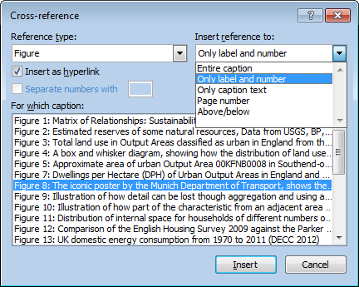

## Updating Automatically Generated Content

Automatically generated content such as cross references, tables of contents, list of figures may need periodic updating. You can either right click on the object and select Update field to update a single area, or to update everything Select All (Ctrl + A) and the press F9. This may take a while on a whole thesis so always save before updating.

# Style Examples

This section includes examples of all the styles used in the template. This text is in the Normal Style and should be used for body text. The Title above is in Heading 1 should be used for chapter titles. It will automatically start a new page and includes some spacing before and after.

Below is a list of heading styles, the template supports up to 6 levels of headings. Only the top three levels appear in the table of contents. Headings appear in the table of contents up to Level 3 and are automatically converted to small caps.

## Heading 2

### Heading 3

#### Heading 4

##### Heading 5

###### Heading 6

###### Heading 6

## Heading 2

### Heading 3

#### Heading 4

##### Heading 5

###### Heading 6

###### Heading 6

Heading 1 – No Number

Heading 1 – No number is used for headings that you don’t want to have heading numbers. For example in the front matter. They do not appear in the table of contents.

Heading 2 – No Number

Heading 2 – No number is used for headings that you don’t want to have heading numbers. For example in the front matter. They do not appear in the table of contents.

* Bullet Style for bullet points
  + Bullet Level 2

Figure 3.: This is a picture of a running kitten. In addition, this caption style is used to caption pictures and tables. Captions include the numbering system included the chapter number. Captions default to above content.

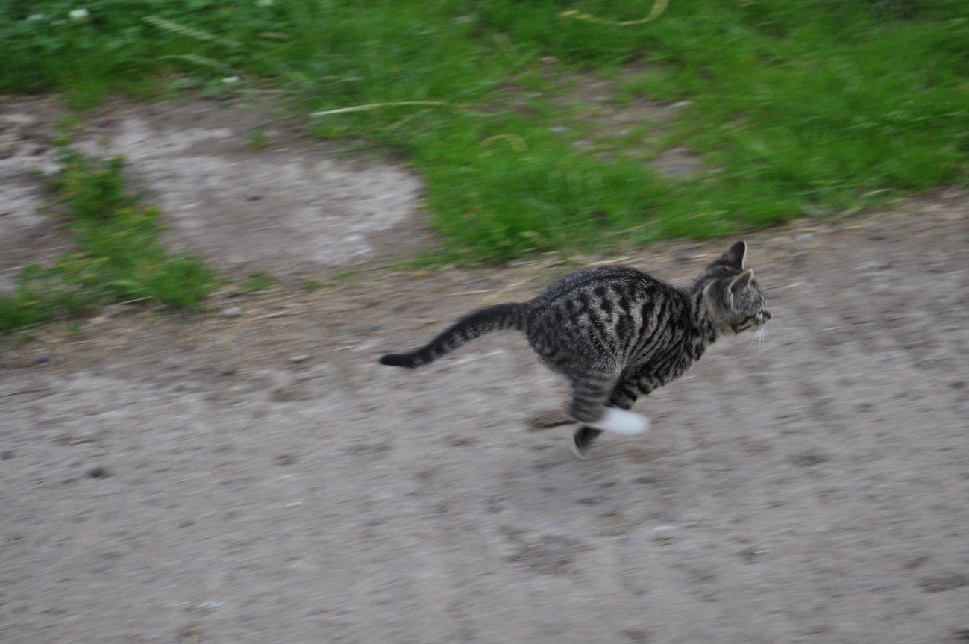

Table 3. This is the caption to a table, and the styles used in tables.

|  |  |  |
| --- | --- | --- |
| Table Head Text | Table Head Text | Table Head Text |
| Table Text | Table Text | Table Text |
| 1. Table Text Numbered | 1. Table Text Numbered | 1. Table Text Numbered |
| Table Text Tab | Table Text Tab | Table Text Tab |

This is what it looks like to add a footnote[1], and this is how endnote looks[2].

This is a quote

This is a dedication; use it for the dedication and quotes in the front matter.

This is a list

List 2

List 3

List 4

List 5

1. Numbered List Part 1
2. Number List Part 2
3. Numbered List Part 3

Table of Figures

This is the text used in tables of figures, tables, appendices etc

Appendix Heading 1

This heading called Appendix Heading should only be used for heading appendices, and it will automatically appear in the list of appendices. It will automatically start a new page.

# References

Bournemouth University, 2005, *Citing References*, [www.bournemouth.ac.uk/academic_services/documents/Library/Citing_References.pdf](http://www.bournemouth.ac.uk/academic_services/documents/Library/Citing_References.pdf). [Accessed August 2006].

# Appendices

Appendix Heading 1 16

Appendix 1 Example Title 26

Appendix 2 27

Appendix 1 Example Title

As a default, appendixes do not appear in the table of contents but instead have their own table of appendices.

To achieve this appendices have their own heading style, which is visually similar to the main headings but are functionally different.

The Appendices do require the chapter heading page so that the beginning of appendices is listed in the table of contents and so that the footers say Appendices rather than saying References.

Appendix Headings automatically start on a new page.

Appendix 2

1. This is a foot note
2. This is an endnote they will automatically be places at the end of the document section. As default this is at the end of the references.